Brain Tumor Segmentation

**Introduction**

The objective of this project is to perform brain tumor segmentation on MRI (Magnetic Resonance Imaging) images using different deep learning architectures like U-Net, Inception U-Net, and VGG. Brain tumor segmentation plays a critical role in medical imaging for accurate diagnosis and treatment planning. The goal here is to automatically delineate and identify tumor regions from MRI scans, aiding healthcare professionals in analyzing the extent and characteristics of the tumor.

**Dataset Description**

The dataset utilized for this brain tumor segmentation task comprises two distinct folders (images and masks), each containing 3064 PNG images. The images are grayscale and possess dimensions of 512x512 pixels, portraying MRI scans of the brain.

The Masks images serve as ground truth labels or masks, indicating the specific regions of brain tumors present in the corresponding MRI scans.

Masks are binary, depicting tumor regions in white and background in black, aiding in the segmentation process.

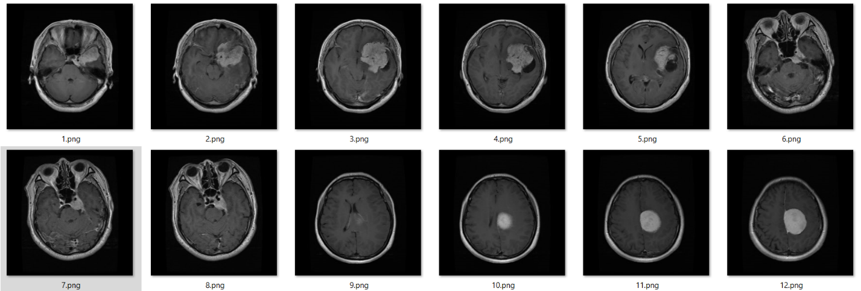

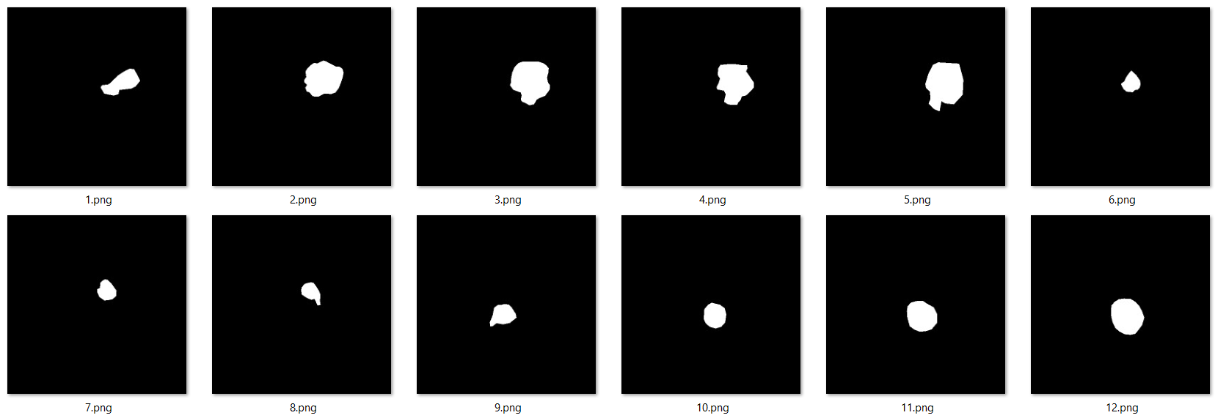

**Methodology**

The methodology employed for brain tumor segmentation involved the utilization of various convolutional neural network (CNN) architectures tailored for semantic segmentation tasks. Three distinct architectures—U-Net, Inception U-Net, and VGG—were implemented and assessed for their effectiveness in accurately segmenting brain tumor regions from MRI scans.

1. **U-Net**

The U-Net architecture, introduced by Ronneberger et al., is a widely adopted CNN architecture renowned for its success in biomedical image segmentation tasks. Its architecture comprises an encoder-decoder structure, where the encoder extracts features from input images while the decoder reconstructs the spatial information to generate segmentation masks.

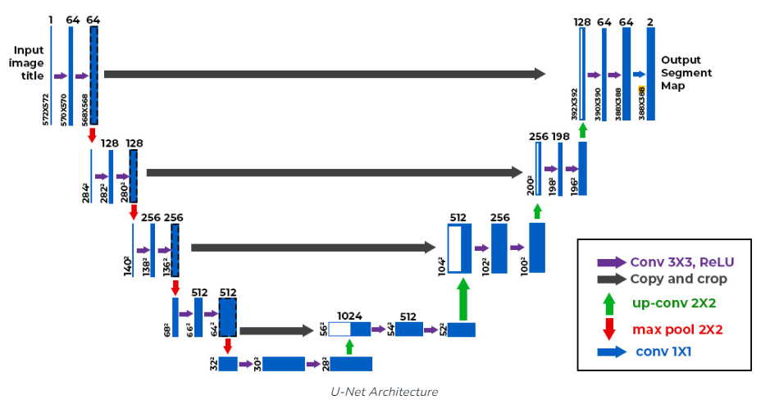

1. **Inception U-Net**

The Inception U-Net architecture amalgamates the robust feature extraction capabilities of the Inception modules with the U-Net's segmentation prowess. This architecture enhances the feature learning process by integrating Inception blocks within the U-Net's encoder and decoder pathways. The Inception modules, characterized by their inception blocks featuring multiple filter sizes concatenated in parallel, allow the network to capture multi-scale information efficiently, contributing to improved segmentation performance.

1. **VGG for Segmentation:**

The VGG architecture, proposed by Simonyan and Zisserman, is primarily recognized for its effectiveness in image classification tasks.The VGG encoder extracts high-level features from input images, which are subsequently decoded to generate segmentation masks. The VGG architecture's stack of convolutional layers enables the extraction of intricate features from MRI scans, aiding in the accurate delineation of tumor regions.

**Methodological Steps:**

* **Data Preprocessing:**

The dataset consisting of 3064 MRI images and corresponding masks (each sized at 512x512 pixels) was preprocessed. This involved loading the images, resizing them to a standard size (256x256 pixels), normalization, and splitting into training, validation, and test sets.

* **Model Implementation and Compilation:**

TensorFlow and Keras libraries were utilized to implement the U-Net, Inception U-Net, and VGG architectures. The models were compiled using appropriate loss functions (such as Dice loss), optimizers (e.g., Adam), and evaluation metrics (Dice coefficient, accuracy).

* **Training Procedure:**

The training process involved 50 epochs for each architecture with a defined batch size and a learning rate of 1e-3.

* **Model Evaluation:**

The trained models were evaluated using the validation dataset to assess their segmentation performance. Metrics like Dice coefficient and accuracy were computed to gauge the models' ability to accurately segment brain tumor regions.

|  |  |  |  |
| --- | --- | --- | --- |
| Architecture | Loss | Dice Coefficient | Accuracy |
| U-Net |  |  |  |
| Inception U-Net | **0.6489** | **0.3508** | **0.9819** |
| VGG |  |  |  |

**Sample Of Predicted and Actual Masks**

